Proposed West Chatham Neighborhood Center District
- Purpose
The purpose of the West Chatham Neighborhood Center (WCNC) District is to:
- Implement the goals in the Town of Chatham’s Comprehensive Plan.
- Create a stronger connection between community vision, regulations, and development plans and generate predictable development outcomes.
- Enhance the character of the WCNC and promote the adaptation of existing buildings to permit redevelopment.
- Promote multi-modal, especially pedestrian-friendly, design and development.
- Encourage more efficient land use through flexible parking requirements.
- Encourage the creation of a range of housing opportunities attainable to year-round residents of all income levels.
- Provide a mechanism by which residential development can contribute in a direct way to increasing the supply of affordable and attainable housing in the WCNC by establishing a minimum 20% inclusionary housing requirement.
- Applicability
Relationship to Other Regulations: The provisions in this Section (Section III.C.9. West Chatham Neighborhood Center District) apply to all development within the WCNC. New dimensional regulations, parking space requirements, permitted uses, and uses allowed by Special Permit or Site Plan Review apply in this district. Other sections of the Town of Chatham Protective Zoning Bylaw also apply within this district, except that where this Section conflicts with or differs from other sections of the Chatham Protective Zoning Bylaw, this Section shall control.
- LOCATION AND AREA
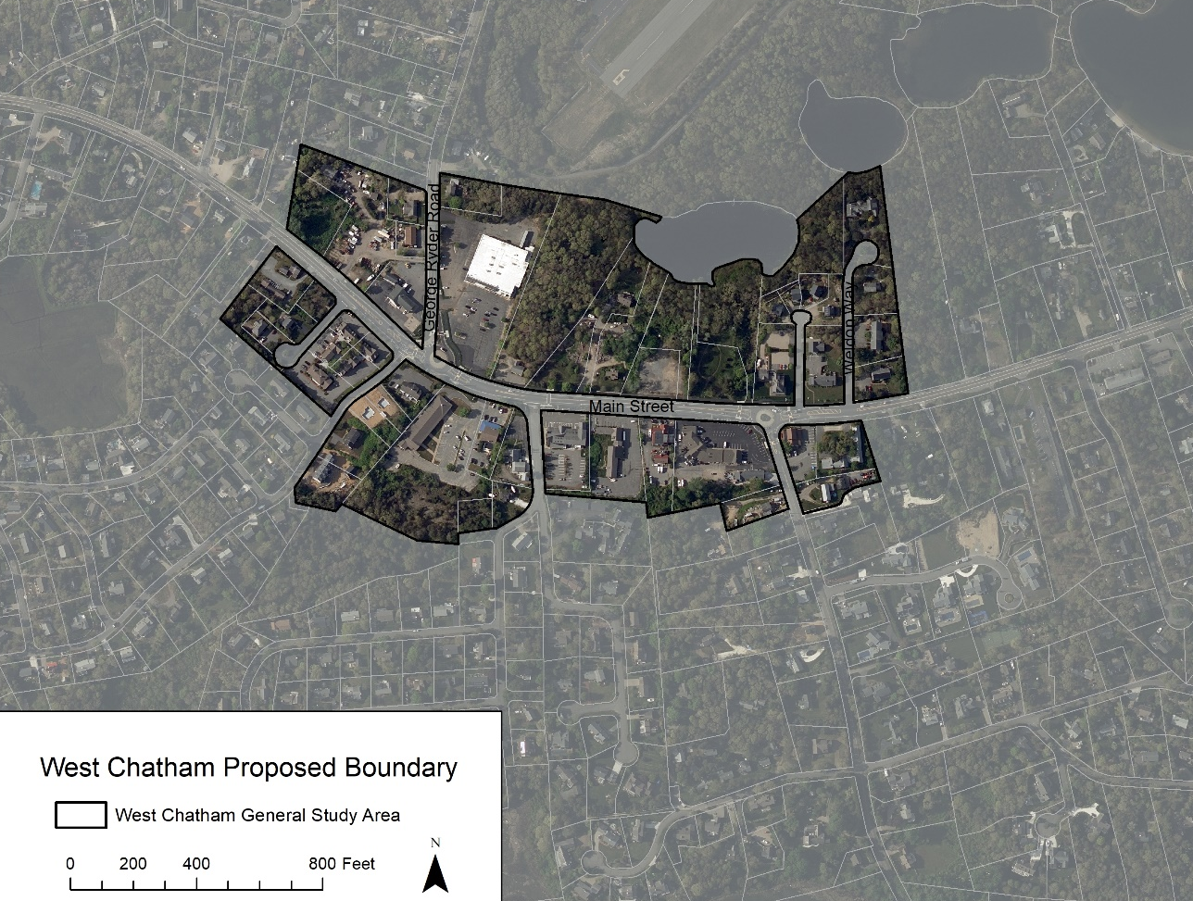

- Procedure
The Planning Board shall be the Special Permit Granting Authority for Special Permit uses within the WCNC District. All new development and redevelopment is subject to Section VI.A Site Plan Review of the Chatham Zoning Bylaw except where small additions/alterations to existing buildings qualify for staff administrative review as defined below.
A pre-existing, non-conforming structure or use may change or expand up to 200 square feet of gross building footprint or exterior of building or site area through Staff Plan Review in accordance with the Site & Building Standards for the WCNC provided it does not involve demolition of significant parts of an historic structure. Said application shall be made to the Planning Department and a written decision shall be rendered within 30-days of receipt. Said decision shall be consistent with the Site & Building Standards for the WCNC and may be appealed to the Planning Board with written notice within 10 days. Said decision shall lapse two (2) years from the date of issuance unless construction or operation under the approval has commenced.
- Definitions
As used in the WCNC, the following terms shall have the meanings indicated:
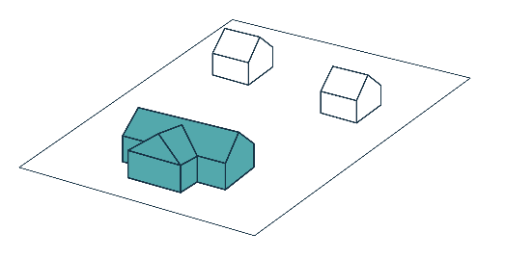
Building Footprint: The total area contained within the exterior walls of a single building as measured at the ground level, including porches, any area underneath cantilevered portions of the building, and other attached components that have roofs, but excluding decks and any other permanent structures which do not have roofs.
Primary Building: The building sited closest to the road frontage.
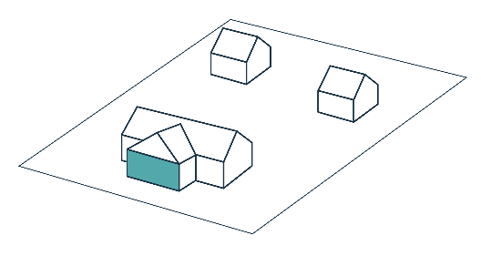
Primary Façade: The front plane of the building wall closest to the road frontage, not including stoops, porches, or other appurtenances, and measuring at least 25 feet.

Building Frontage Occupancy: The percentage of lot frontage within 20 feet of the minimum road setbacks that is occupied by a building façade that is parallel to the frontage. Building frontage occupancy is calculated by taking the combined width of the building façade(s) parallel to the frontage and within 20 feet of the minimum road setbacks and dividing by the width of the frontage.
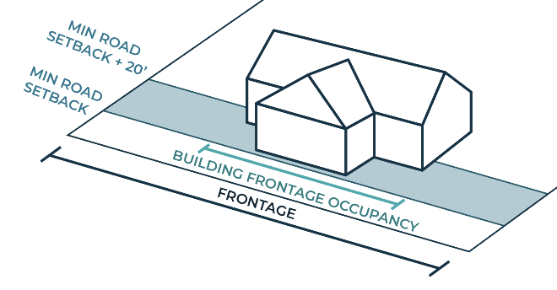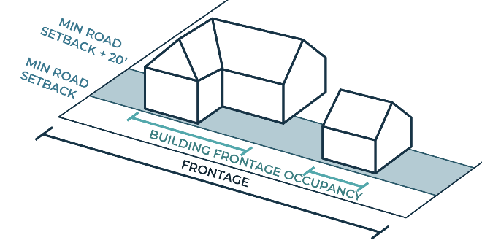
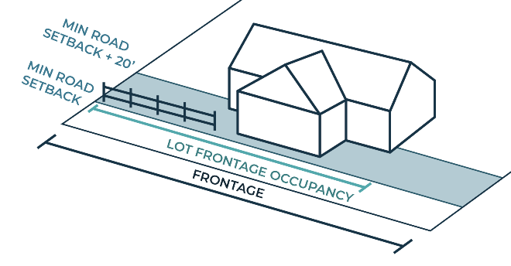
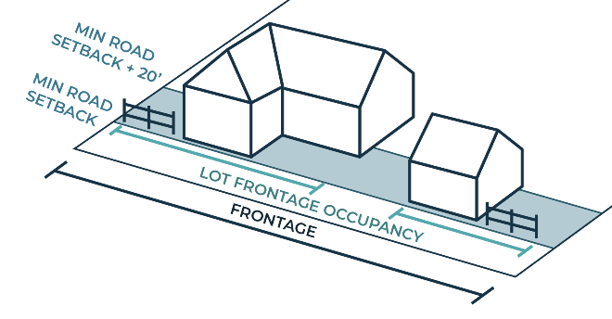
Lot Frontage Occupancy: The percentage of lot frontage within 20 feet of the minimum road setbacks that is occupied by a building façade parallel to the frontage, low stone wall, or low fencing in combination with landscape plantings to create a consistent street wall. Lot frontage occupancy is calculated by taking the combined width of the building façade(s) parallel to the frontage, low stone wall, and/or low fencing within 20 feet of the minimum road setbacks and dividing that total by the width of the frontage.

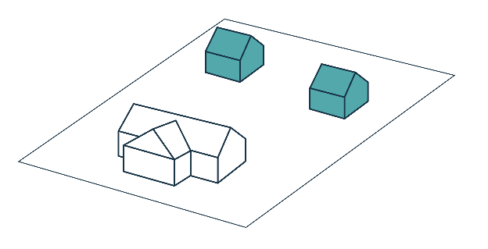
Secondary Building(s): On properties with multiple buildings, those buildings other than the Primary Building.
Transparency: The measurement (percentage) of clear glass within a solid wall along a building façade.
- SubZones

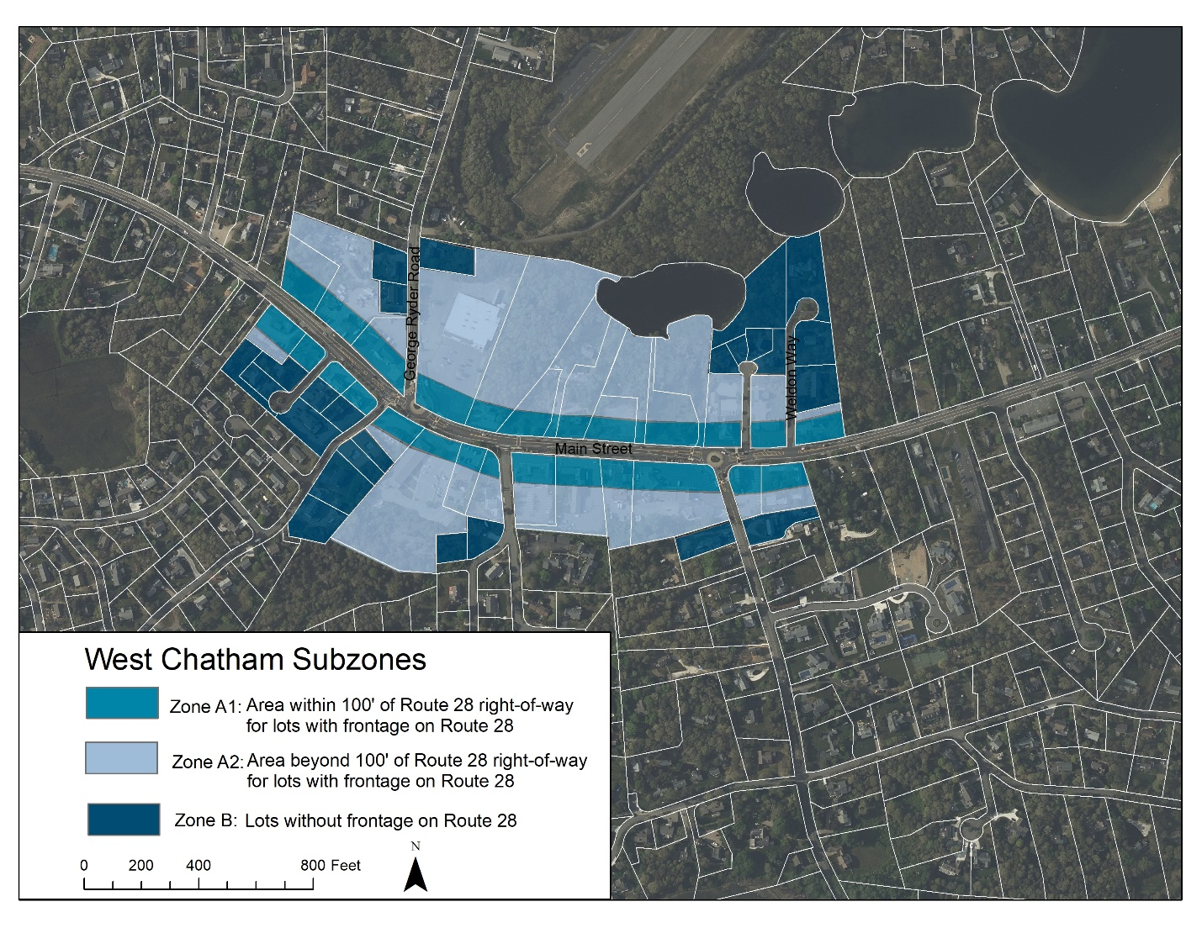
ZONE A1: Area within 100’ of Route 28 right-of-way for lots with frontage on Route 28
ZONE A2: Area beyond 100’ of Route 28 right-of-way for lots with frontage on Route 28
ZONE B: Lots without frontage on Route 28
- Mandatory provision of affordable And attainable housing for development of new residential units
Any new or rehabilitated development involving two or more dwelling units shall provide 20% of the dwelling units as deed restricted affordable and/or attainable housing units. The applicant shall meet the requirement by either constructing and deed restricting in perpetuity a dwelling unit(s) or, by a Payment-in-Lieu of providing a fractional unit in accordance with the following:
- For 2 new dwelling units, the Payment-in-Lieu is equal to 40% of the cost of a unit in the development.
- For 3 new dwelling units, the Payment-in-Lieu is equal to 60% of the cost of a unit in the development.
- For 4 new dwelling units, the Payment-in-Lieu is equal to 80% of the cost of a unit in the development.
- Density
All zones:
- Residential density shall be a minimum of 5 dwelling units per acre
Density bonus for providing at least 25% of new dwelling units as affordable and/or attainable units:
- Up to 2.4 times the base density, up to a maximum of 12 dwelling units per acre
- Required affordable and/or attainable dwelling unit(s) shall be constructed as part of the project
- Distribution of affordability shall be as follows:
  - 1st unit shall be affordable to households earning 90% AMI and eligible for inclusion on the Town’s Subsidized Housing Inventory
  - 2nd unit shall be affordable to households earning 100% AMI
  - Additional units may be affordable to households earning between 80% and 125% AMI
- A Payment-in-Lieu shall be required for “fractional units” based on the 25% affordability requirement for the total number of dwelling units developed
- Lot Standards
- Minimum Lot Size: 10,000 square feet
- Minimum Lot Frontage: 100 feet
- Maximum Lot Coverage: 60%
- Site & Building Standards
- Building Setbacks - Zone A1
- Minimum Road Setback: 10 feet
- Maximum Road Setback for Primary Building: 20 feet
- Maximum Road Setback for Secondary Buildings: no maximum
- Minimum Abutter Setback: 8 feet except when abutting a residential zone, in which case it is 15 feet
- Building Setbacks - Zone A2
- Minimum Road Setback (non-Route 28): 10 feet
- Maximum Road Setback (non-Route 28): no maximum
- Minimum Abutter: 10 feet except when abutting a residential zone, in which case it is 15 feet
- Building Setbacks - Zone B
- Minimum Road Setback: 10 feet
- Maximum Road Setback for Primary Building: 30 feet
- Maximum Road Setback for Secondary Buildings: no maximum
- Minimum Abutter Setback: 10 feet except when abutting a residential zone, in which case it is 15 feet
- Parking Setbacks
- Parking in front yard is prohibited in all zones.
- Zones A1 & B Minimum Parking Setback: 10 feet behind the primary building façade
- Zone A2 Minimum Parking Setback: 30 feet from all road frontages
- All Zones
The SPGA may allow a pre-existing, non-conforming structure or use that has parking in front to alter or expand up to 1,000 square feet of gross building footprint or exterior of building or site area in accordance with the Site & Building Standards for the WCNC District if there is no increase in the pavement in the road setback and the property:
- Provides a new frontage building that is consistent with building setback and building form sections of the WCNC District; or
- Provides a 15-foot deep landscape buffer along the Route 28 road frontage to screen paved parking areas; or
- Removes a second access point onto Route 28 in combination with landscape buffer improvements.

Building Form
- Building Frontage Occupancy Minimum
- Zone A1: 50%
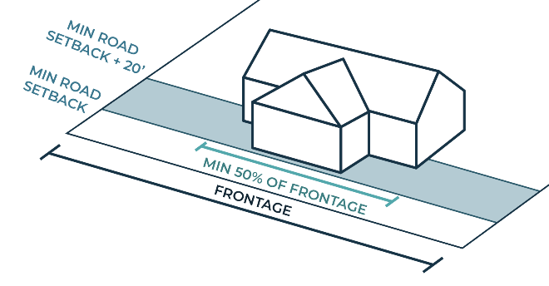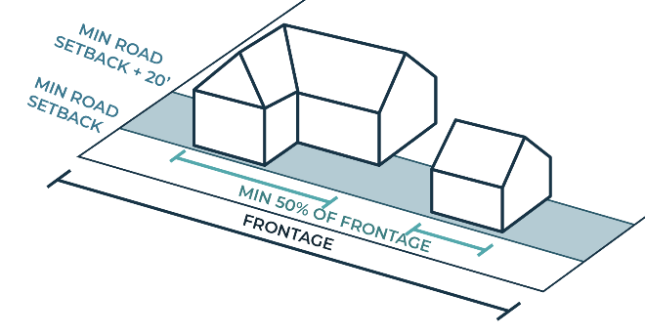
- Zones A2 & B: No Minimum
- Building Height Maximum
- All zones: 2 stories (not to exceed 30 feet as measured from the grade plane to the highest point of a structure or roof surface)
- All zones: If a residential development includes a certain amount of deed-restricted affordable housing units, the maximum height allowed is 2.5 stories (though still not to exceed 30’).
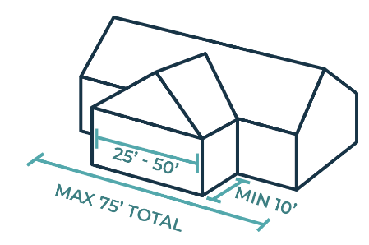
- Building Façade Width Maximum
- All zones: The primary façade width shall not exceed 50 feet. The total street-facing façade width shall not exceed 75 feet. Street-facing façades adjacent to the primary façade shall be stepped back at least 10 feet, have distinct roof forms, and shall not be wider than the primary façade.
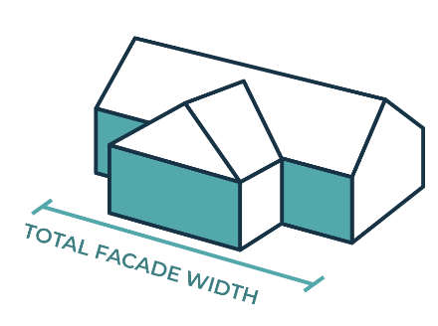
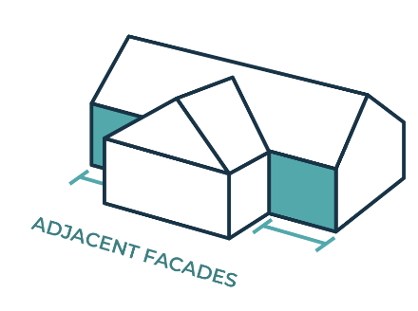
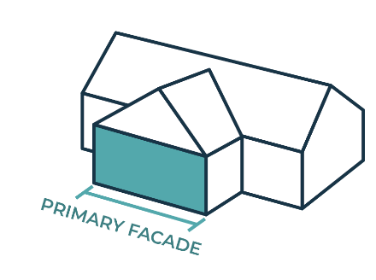

- Building Footprint Maximum
All zones have a maximum building footprint per building, however multiple buildings are allowed on a single lot.
- Zone A1: 3,000 square feet per building
- Zone A2: 5,000 square feet per building
- Zone B: 4,000 square feet per building
- Building Features
- Zone A1:
  - Minimum Façade Transparency:
    - Ground story: 35% minimum for street-facing façades (for non-residential uses)
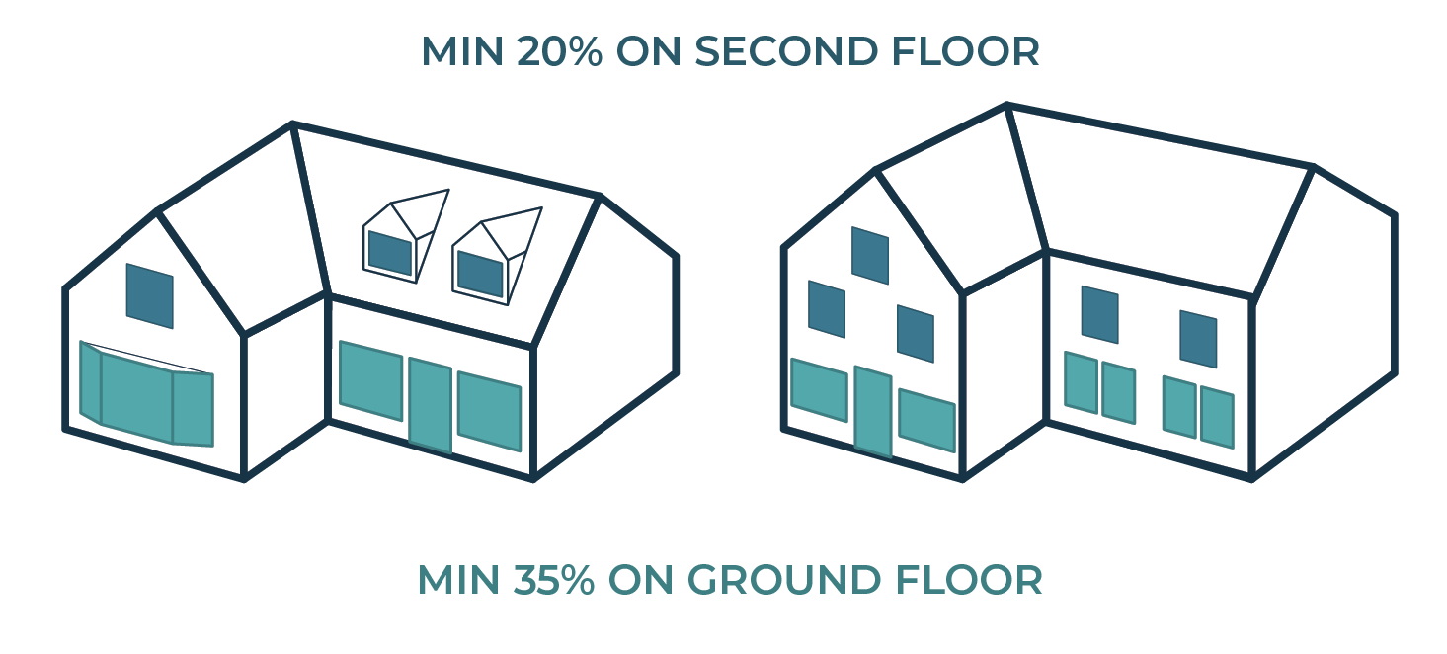
    - Upper story: 20% minimum for street-facing façades
    - The percent transparency shall be calculated by dividing the area of the solid wall that is clear glass—glass within windows and doors—by the total area of the solid wall. Tinted and mirrored glass is prohibited on the ground floor.
    - Exception for historic structures to maintain historic window configuration
  - Principal Entry: A principal entry is required on the Route 28 façade. Additional entries may be located on other building facades.
- All zones:
  - Building Materials: Traditional wood clapboard and shingles, or similar alternative materials approved by the HBDC, required.
  - Roof Slope: minimum pitch of main roof 6:12; dormers must be set back from the sides of the roof plane by at least 5 feet and cover no more than 50% of any roof plane; no flat roofs, consistent with HBDC guidelines.
  - Historic Features: Protect and preserve distinctive architectural features and trim on buildings significant in the Chatham’s history, consistent with HBDC guidelines.
  - Utilities Screening: Mechanical and utility equipment should be located where it can be visually screened by buildings or vegetation, walls, or fences, consistent with HBDC guidelines.
  - Utilities for new development should be located underground within the property.
- Streetscape Standards
- All zones: The front yard area may contain pedestrian access and amenities such as walkways, benches, dining areas, and other outdoor accessory uses. Awnings, balconies, and architectural features may project into the front yard area. Porches, stoops, fencing and similar structures may be located within the front yard area.
- All zones: Parking is prohibited in the front yard area.
- Lot frontage occupancy
- Zone A1: minimum 70%
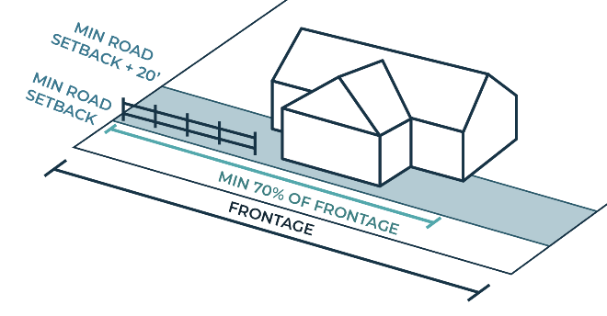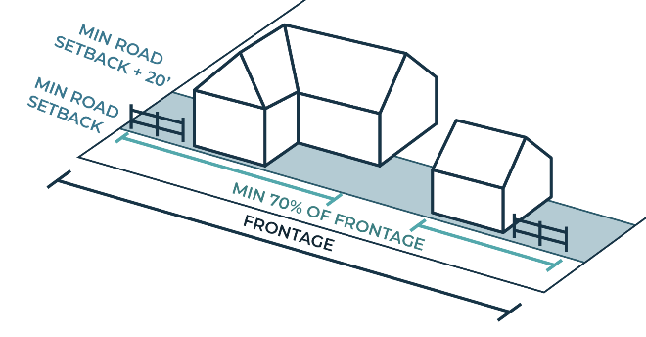
- LANDSCAPE STANDARDS
Landscaping in Area Adjacent to the Street
Landscaping shall be required in the road setback/front yard area for all uses in the West Chatham Neighborhood Center to maintain a pedestrian-friendly streetscape, improve community character, and screen and buffer parking from the sidewalk.
- Street trees: Provide at least one shade tree (2-inch caliper dbh) per 40 feet or fraction thereof of lot frontage. Trees may be placed at any spacing along the front of the property. The Planning Board, in consultation with the Tree Warden, may waive or reduce the street tree requirement if existing street trees make additional trees unnecessary.
- Landscaping between road and building: Plant this area with grass or other ground cover or approved surface for outdoor seating areas and include appropriate trees and shrubs.
- Landscaping between road and parking areas: Provide at minimum an 8-foot-deep planting strip with shrubs and/or trees and/or a low fence or landscape wall (2-3 feet high)
- Transition Buffer to Residential Zones
A landscaped buffer area shall be required along all boundaries of a non-residential lot abutting any lot in a residential zone to effectively screen activity and provide privacy from noise, headlight glare, and visual intrusion to residential dwellings.
- Buffer Location: Buffer area shall be located within the boundaries of the subject property
- Buffer Depth: Minimum buffer depth shall be 15 feet
- Buffer Plantings: At least 2 staggered rows of evergreen trees six feet in height, planted at intervals of 10 feet on center. Non-evergreen planting, a landscaped earthen berm, wall, or fence, or mature existing vegetation may also be determined to meet the intent of this section at the discretion of the planning board.
- Landscaped Parking Area
All uses required to provide 20 or more off-street parking spaces must provide landscaping within the parking area to break-up the expanse of asphalt and provide areas for pedestrian circulation, shade, and stormwater treatment/rain gardens as appropriate.
- Interior Landscape Area: Provide at least 10 square feet of interior parking lot landscaping per parking space, planted with a combination of grass and shrubs and at least one tree as noted below
- Parking lot trees: Provide at least one shade tree (2-inch caliper dbh) for every 10 parking spaces or fraction thereof
- Perimeter buffer: Provide at least 4 feet of landscape buffer (which may be part of the transition buffer, if required) along the outer perimeter of any parking area except that portion of the parking area which provides access to a street or parking facility on an adjacent lot, planted with a combination of grass or groundcover and shrubs and at least one tree (2-inch caliper dbh) for every 40 feet along the perimeter
- Flexibility
Where lot size and shape or existing structures do not make it feasible to comply with the requirements for front yard landscaping or landscaped parking area, the Planning Board may approve planters, plant boxes or pots containing trees, shrubs and/or flowers to comply with the intent of these regulations.
- Parking Requirements & Access Standards
Parking in the West Chatham Neighborhood Center shall be provided in compliance with Section VI.B Parking Requirements of the Chatham Zoning Bylaw except that Section VI.B.6 Required Spaces shall be replaced by the West Chatham Neighborhood Center parking requirements table below.
- Required Parking Spaces
Off-street parking spaces in the amounts specified in Table of Parking Requirements shall be provided for each use, unless an alternate amount is approved through Site Plan Review, in accordance with the Waiver Requests section.
Table of Parking Requirements (spaces per 1,000 s.f. unless otherwise noted)
Land Use | Maximum | Minimum
General Retail | 3 | 2
General Office | 4 | 2
Hotel, Motel, Lodgings | 1.5 space per sleeping room | 1 space per sleeping room
Medical Office | 6 | 3
Restaurant | 10 spaces per 1000 sf or 1 space per 4 seats plus 1 space per every 2 employees during largest shift | 6 spaces per 1000 sf or 1 space per 5 seats
Coffee shop/cafe | 1 space per 2 seats | 1 space per 3 seats
Personal Services Establishment | 3 | 2
Residential | 2 per dwelling unit | 1 per dwelling unit
Social, Fraternal Organizations | 4 | 3
Churches, places of worship | 1 space per 3 seats in part of building used for services | 1 space per 5 seats in part of building used for services
All other uses | 3  or other amount, as determined by the  Planning Board based on the character of the use proposed | 2  or other amount, as determined by the  Planning Board based on the character of the use proposed
Bike Parking
Commercial uses | Minimum of 5 bike rack parking spaces per establishment plus an additional space per 10 vehicle parking spaces
Residential uses with 4 or more dwelling units | Secure parking for bicycles shall be provided, with the amount and location to be determined during Site Plan Review.

- Waiver Requests
Applicants may seek a waiver from the Planning Board and the Planning Board shall have the authority through Site Plan Review to reduce the minimum number of parking spaces required by 25% or to exceed the maximum amount by up to 10% in accordance with the process laid out by Section VI.B.7.b. Exceptions of the Protective Bylaw.
C. Shared Parking
The number of parking spaces required may be reduced for shared parking at the discretion of the Planning Board provided such reduction does not shift a demand for parking onto public streets or any areas not equipped to handle such activity.
1. Shared On-Site Parking
To implement shared on-site parking between two or more uses, the applicant shall provide expert analyses as part of Site Plan Review to demonstrate that proposed uses are either competing or non-competing and the applicant shall pay for peer review as and if required by the Planning Board.
2. Non-competing Uses
In multi-use developments, applicants may propose a reduction in parking requirements based on an analysis of peak demands for non-competing uses. The parking requirements for the predominant use (i.e., the use with the most floor area) may be reduced by up to 50% by the Planning Board if the applicant can demonstrate that the peak demands for two uses do not overlap. An applicant may use the latest peak demand analyses published by the Institute of Traffic Engineers (ITE) or other source acceptable to the Planning Board and the Planning Board may require peer review of the information provided.
3. Competing Uses
In a multi-use development, an applicant may propose a reduction in parking requirements where peak demands do overlap. In these cases, the Planning Board shall have the authority, but not the obligation, to reduce the parking requirements of the predominant use by up to 30%.
In consideration of a request to share parking, the Planning Board shall require that an applicant provide evidence that satisfies the Planning Board that the following conditions are met:
a. The shared parking is sufficient to adequately service the adjoining uses without leaving either in a deficit of spaces needed;
b. The shared parking has well defined pedestrian access to both uses;
c. There is a legally binding agreement, executed by all parties to be served and recorded, which permits vehicular and pedestrian access to and from all the parcels involved; this agreement must be in place, and a copy provided to the Building Inspector before issuance of an Occupancy Permit.
D. Bicycle Parking
- The bicycle parking facilities shall not encroach on any area in the public right-of-way intended for use by pedestrians, nor shall they encroach on any required fire egress.
- During Site Plan Review the Planning Board shall consider both short-term bicycle parking for visitors as well as long-term parking and storage needs for residents.
E. Access Standards
1. Shared Driveways
Driveways that can be shared for more than one property are encouraged, provided the Planning Board determines that sharing does not limit adequate service or emergency access at any time.
- Maximum access drive width: 24 feet
2. Cross Access
- Providing vehicular cross access to an abutting property is encouraged.
- Maximum width for cross access drive: 24 feet
Customer and residential pedestrian access areas shall include a combination of walkways and landscaping. Such pedestrian access shall be provided from the streets providing frontage and/or access for the project as well as the drives and parking areas within the project. Pedestrian access routes shall be laid out to minimize conflict with vehicular routes, and where the two cross, the pedestrian route shall be clearly marked on the vehicular surface and when appropriate, with signage.
- Permitted Use Provisions
Uses within the West Chatham Neighborhood Center district are subject to Zone regulations as established in Section ___ and defined by Section ___ Definitions.
Uses not listed in the Permitted Use Provisions that are similar in character, scale, and impact to Permitted Uses may be allowed if determined by the Building Commissioner to be consistent with the regulations and intent of this Article. Multiple permitted commercial uses may be allowed on a single lot or in a single building, according to the most restrictive permitting provisions among them (i.e., two standard permitted commercial uses may be permitted through the standard permitting process but a standard permitted use and a special permit use may be permitted through the special permit process).
P = Standard permitted Use in West Chatham Neighborhood Center district; SC = a permitted use in the West Chatham Neighborhood Center district provided it complies with the Special Use Regulations provided in Section ___ below; SP = a use which is authorized by the Special Permit Granting Authority after a public hearing, provided that it meets the general and specific standards and conditions set forth in Chapter 40A of Massachusetts General Laws and Section VII of this Bylaw.
Accessory structures that comply with all of the regulations of the West Chatham Neighborhood Center are allowed per the permitted use provisions table.

 | Use | Zone A1 | Zone A2 | Zone B
Commercial | Bank | P | P | P
Commercial | Conservation of Natural Features | P | P | P
Commercial | Formula Business Establishment | SP | SP | SP
Commercial | Low Intensity Recreational Use | P | P | P
Commercial | Lunch Room | SC | SC | SC
Commercial | Medical Clinic | P | P | P
Commercial | Motel, Hotel and Inn | SP | SP | SP
Commercial | Personal and Household Services | P | P | P
Commercial | Private Educational Use | P | P | P
Commercial | Professional Office | P | P | P
Commercial | Public Educational Use | P | P | P
Commercial | Religious and Municipal Use | P | P | P
Commercial | Restaurant | SC | SC | SC
Commercial | Retail Sales and Service | P | P | P
Commercial | Roadside Stand | P | P | P
Commercial | Tourist Home | SC | SC | SC
Mixed Use | Mixed Use Development (A building or buildings in which there are a mix of permitted commercial use(s) and dwelling unit(s)) | SP | SP | SP
Mixed Use | Home Occupation | P | P | P
Residential* | Affordable Apartment Incidental to a Single Family Dwelling (for pre-existing single family dwellings) | SP | SP | SP
Residential* | Conversion of Existing Dwelling to Multi-family Dwelling | SC | SC | SC
Residential* | Dormitories | X | X | X
Residential* | Multi-family Dwelling  (including townhouses, duplexes, etc.) | X | P | P
Residential* | Accessory Dwelling Unit | P | P | P
Residential* | One Single-Family Dwelling per Lot | X | X | X
X – Not permitted P – Standard permitted use SC – Special condition SP – Special permit
*Residential uses are allowed in below-ground stories as long as they meet requirements for natural light and egress.
- SPECIAL USE REGULATIONS
A. Lunch Room – See Section VII B. of the Town of Chatham Protective Zoning Bylaw
B. Restaurant – See Section VII B. of the Town of Chatham Protective Zoning Bylaw
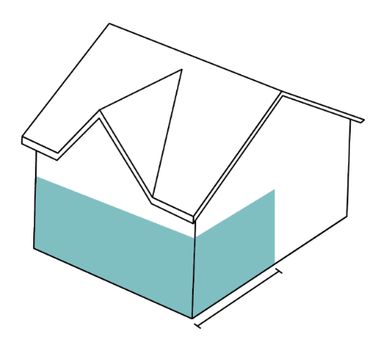
C. Tourist Home – See Section VII B. of the Town of Chatham Protective Zoning Bylaw
ROUTE 28
30’+
D. Mixed Use Development – In the A1 zone, the first 30’ of the ground floor area facing Route 28 must be used for a permitted commercial use(s); the upper floor and other ground floor space can be used for dwelling unit(s) or other commercial use(s). It must also comply with all other regulations of the West Chatham Neighborhood Center District.
E. Conversion of Single Family Dwelling to Multi Family Dwelling – Where the single family home proposed for conversion is a historic structure, its key character-defining features shall be preserved.

1. The restrictions established by this bylaw shall not apply to uses and structures lawfully in existence as of the effective date hereof and located within the Runway Protection Zone shown in the Airport Master Plan Updated February 2021, Figure 2-4: Runway Protection Zone Dimensions – Runway 6-24. 2. Lot development and redevelopment potential shall be based on the size of the entire lot, however, all new structures and improvements to be developed on a lot must be located outside of the RPZ, except as allowed under section (3) below. 3. Where a lawfully pre-existing structure is located partially within the RPZ, both the pre-existing use(s) and dimensional attributes of said structure shall be considered legal pre-existing non-conformities. - Redevelopment is allowed by right within the RPZ portion of the lot for the same use, existing square footage, and existing height. There is to be no net increase in square footage of structures within the RPZ and no increase in the height of structures beyond the maximum existing height within the RPZ. - Except as may otherwise be expressly permitted hereby, the redevelopment of a lot must comply with the current use and dimensional requirements of the underlying Zoning District. - A change of use to a use of a similar nature which will not be detrimental to the established or future character of the neighborhood and which will be in harmony with the general purpose and intent of this Bylaw may be allowed by ZBA Special Permit. - Any additions to a single-family home located within or partially within the RPZ which was in existence as of the date of adoption of this bylaw may be allowed up to an additional 50% of existing building square footage, but no additional dwelling unit(s), including ADUs, shall be allowed. Any such addition must comply with all use and dimensional requirements of the underlying Zoning District

